TITLE: M-Pesa Spending Predictor using Machine Learning

Objective:
To develop a web-based machine learning application that analyzes M-Pesa transaction statements and predicts future spending based on user input.

Project Description:
The M-Pesa Spending Predictor is a machine learning-powered web application built with Flask and XGBoost. It allows users to input details of their M-Pesa transactions and get predictions of their expected spending. The system is trained using historical transaction data and uses a combination of preprocessing, encoding, scaling, and regression modeling techniques.

For code review open GitHub account: mpesa prediction

Tools & Technologies:
- Python (Data processing, Model training)
- Flask (API backend)
- HTML/JavaScript (Frontend)
- XGBoost (Regression model)
- scikit-learn (Preprocessing, Evaluation)
- pandas/NumPy (Data manipulation)
- pickle (Model serialization)
- LabelEncoder / StandardScaler
- CORS / flask_restful

Data Used:
Original M-pesa statement (pdf format) is cleaned and anonymized from ['Receipt No', 'Completion Time', 'Details', 'Transaction Status',
'Paid in', 'Withdraw\rn', 'Balance', 'Unnamed: 0']
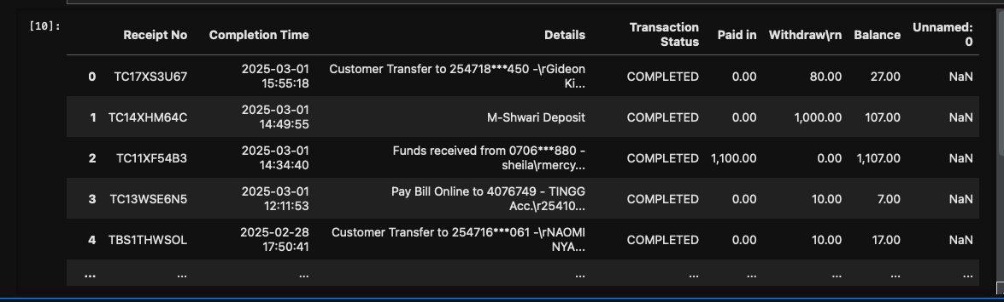

To a
Cleaned M-Pesa transaction CSV with the following features:
- Receipt
- transaction_Day (number of transactions in a day)
- Year
- Month
- Date
- Weekday
- Hour
- Minute
- Seconds
- Transaction_type
- Transaction_party
- Transaction_amount
- paid_in_or_Withdraw
- Balance
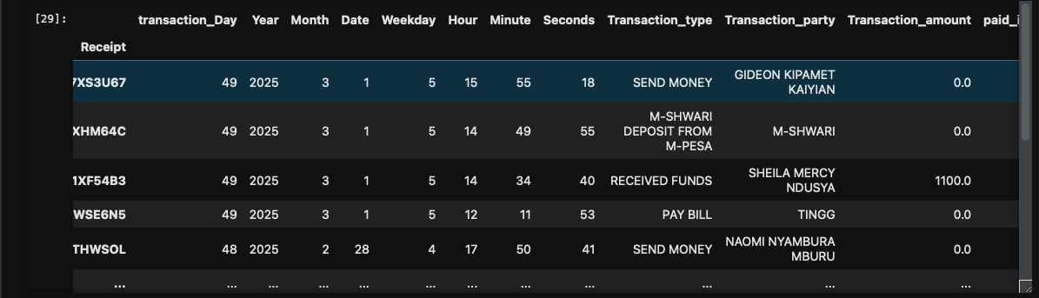

Feature Engineering:
- Extracted relevant time features from the date and time columns.
- Filtered and encoded categorical variables using LabelEncoder.
- Special handling of infrequent Transaction_party values.
- Applied feature scaling using StandardScaler.

Model Training & Evaluation:
- Used XGBRegressor with hyperparameter tuning via GridSearchCV.

Evaluated model using:
- Root Mean Squared Error (RMSE) 40.19
- Mean Absolute Error (MAE) 24.71
- R2 Score 0.47

Flask API:
/Prediction - Accepts POST requests with transaction details and returns predicted spending.
/Data - Returns historical transaction data in JSON format.

Frontend:
- HTML form with fields for Transaction Amount, Type, Party, and Paid/Withdrawn.
- JavaScript to submit data via Fetch API and render results.

Model Saving:
- Serialized trained model, scaler, and encoder into .pkl files for use in the API.

Challenges & Solutions:

- Handled unseen categorical values by mapping them to constant value eg balance 1000.
- Addressed scaling issues by fitting the scaler only on training data.
- Improved model performance via feature selection and parameter tuning.

